CPEG 207 Digital Systems HOMEWORK 3
Name: _______________________________________________
Show your work detail and clearly identify your answer.
- A) Find the value of X for all possible values of the variables.
i) 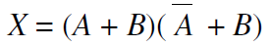
ii) 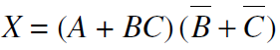

B) Apply DeMorgan’s theorems to each expression:
i) 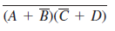
ii) 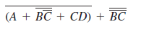
- A) Write the Boolean expression of the logic circuit:
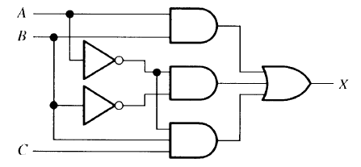
B) Using Boolean algebra, simplify the following expression:
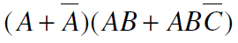
3. Determine which of the following logic circuits are equivalent.
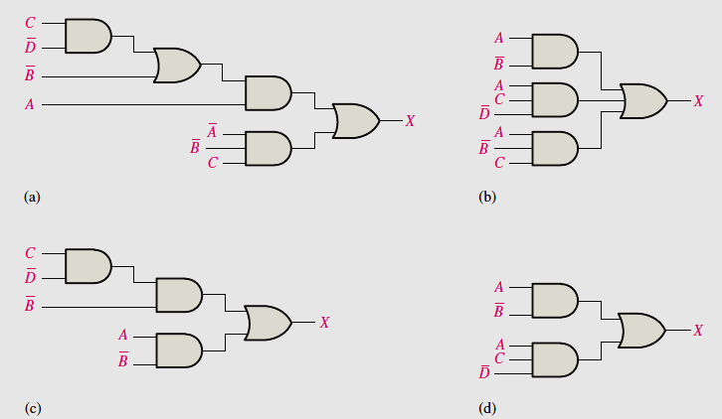
4. Expand each Boolean expression to a standard SOP form and minimize with a Karnaugh map:
A)
B)

5. A) Use a Karnaugh map to find the minimum POS:
B) For the function specified in the table, determine the minimum POS using a Karnaugh map:
